**Load Balancer Tasks**

1) Configure Classic Load balancer.

Step 1: Launch EC2 Instances

Before setting up the load balancer, ensure you have at least **two EC2 instances** running in the **same region** and ideally in **different Availability Zones**.

Step 2: Open Required Ports in Security Groups

Make sure the EC2 instances’ security groups allow:

* **HTTP (Port 80)** or the port your app is running on
* **Health Check Port** (usually same as instance port)

**Step 3: Create Classic Load Balancer**

* **Go to EC2 Console**  
  Navigate to **EC2 → Load Balancers** → Click **Create Load Balancer**.
* **Select Load Balancer Type**  
  Choose **Classic Load Balancer** and click **Create**.
* **Define Load Balancer**
  + - **Name:** MyCLB
    - **Scheme:** internet-facing (or internal)
    - **Listeners:**
      * Load Balancer Protocol: HTTP
      * Load Balancer Port: 80
      * Instance Protocol: HTTP
      * Instance Port: 80
* **Assign Security Groups**
  + Select an existing security group or create a new one allowing traffic on **port 80** (HTTP).
* **Configure Health Check**
  + Protocol: HTTP
  + Ping Path: / (or your app’s health check endpoint)
* Advanced Settings (optional):
  + Healthy threshold: 2
  + Unhealthy threshold: 2
  + Timeout: 5 sec
  + Interval: 30 sec
* **Add EC2 Instances**
  + Select the instances you want to register with the load balancer.
* **Add Tags** (Optional)
* **Review and Create**
* Click **Create**.

Step 4: Test the Load Balancer

* Go to **Load Balancers** section.
* Copy the **DNS name** of the CLB.
* Open it in your browser: http://<CLB-DNS-NAME>

You should see the response from one of your registered EC2 instances.

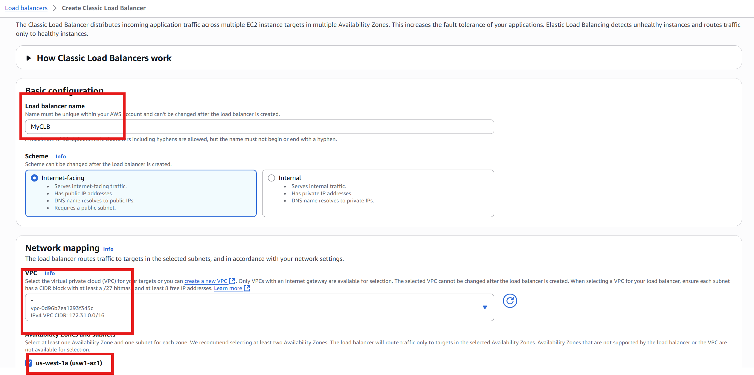

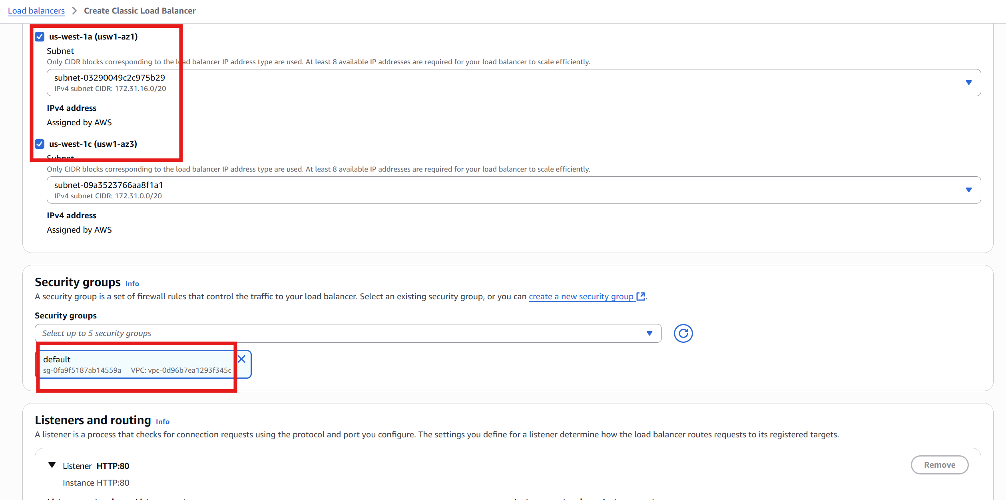

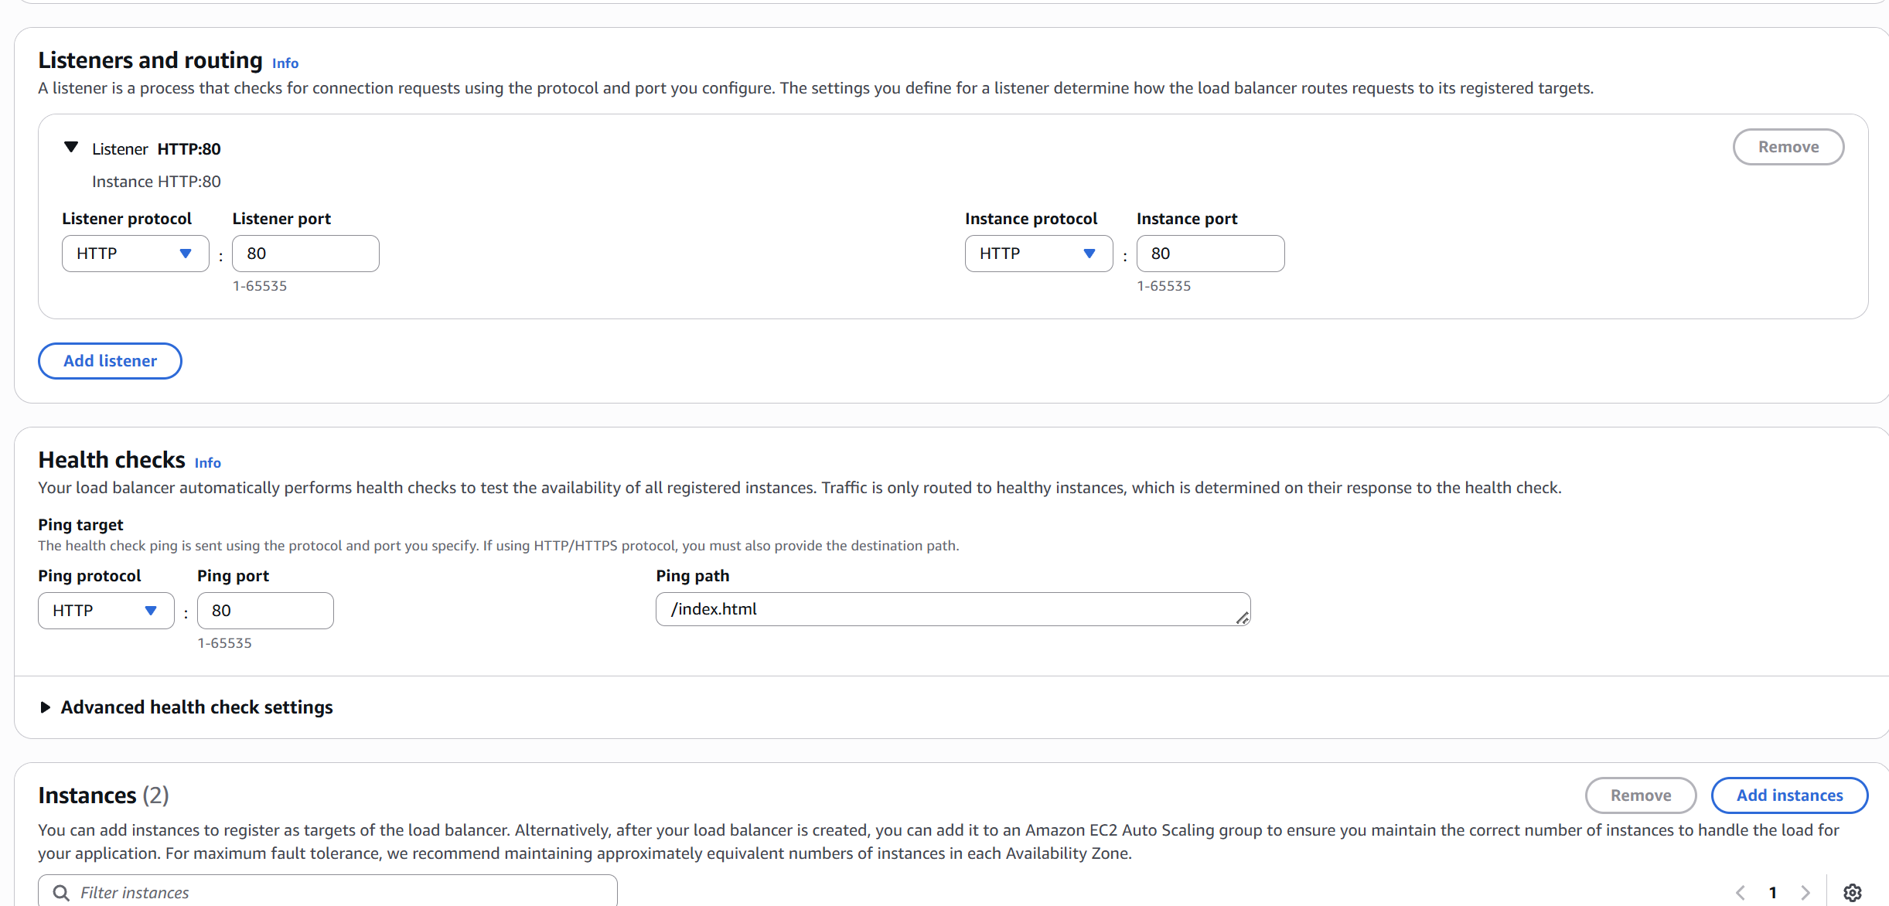

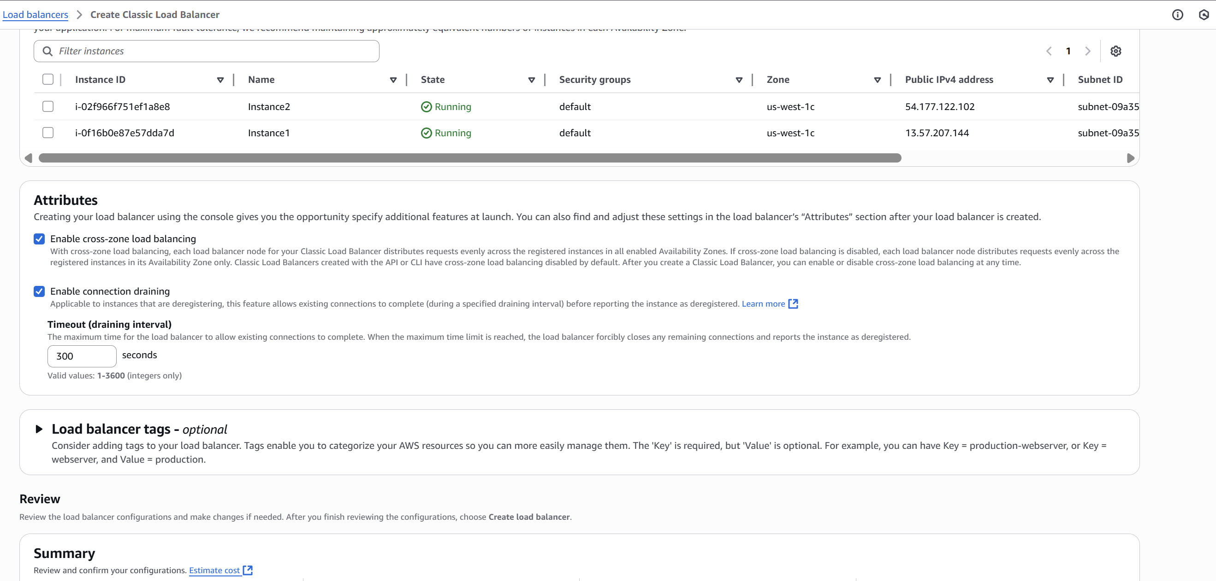

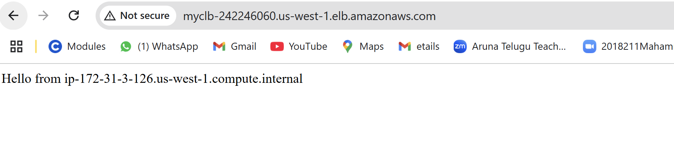

2) Configure Application Load balancer.

Step 1:

Before creating an ALB, make sure:

* + You have **at least 2 EC2 instances** (preferably in different Availability Zones).
  + Instances have a **web server running on port 80** (e.g., Apache, Nginx).
  + EC2 instances are in the **same VPC**.
  + **Security groups** allow HTTP traffic.

Step 2: Create Target Group

* Go to **EC2 Console → Load Balancing → Target Groups**
* Click **Create target group**

**Target group settings:**

* **Choose target type:** Instance
* **Target group name:** my-target-group
* **Protocol:** HTTP
* **Port:** 80
* **VPC:** Select your VPC

**Health checks:**

* **Protocol:** HTTP
* **Path:** / (or your custom health endpoint)

Click **Next**

**Register targets:**

* Select your EC2 instances
* Click **Include as pending**
* Click **Create target group**

Step 3: Create Application Load Balancer

* Go to **EC2 → Load Balancers**
* Click **Create Load Balancer** → Select **Application Load Balancer**

**Basic configuration:**

* **Name:** my-alb
* **Scheme:** internet-facing (or internal if needed)
* **IP address type:** IPv4

**Listeners:**

* **Protocol:** HTTP
* **Port:** 80

**Availability Zones:**

* Choose **at least 2 AZs**
* Select corresponding subnets

Click **Next**

**Step 4: Configure Security Group**

* + **Select an existing security group or create a new one**
  + **Make sure it allows inbound HTTP (port 80) from 0.0.0.0/0**

Step 5: Configure Routing

* **Target group:** Select the one you created earlier (my-target-group)
* **Listener rules:** Default rule forwards to target group

Step 6: Test ALB

1. Go to **Load Balancers**
2. Copy the **DNS name** of the ALB (e.g., my-alb-1234567890.us-west-1.elb.amazonaws.com)
3. Paste into a browser:  
   http://my-alb-xyz.us-west-1.elb.amazonaws.com

You should see the web page from one of your EC2 instances.

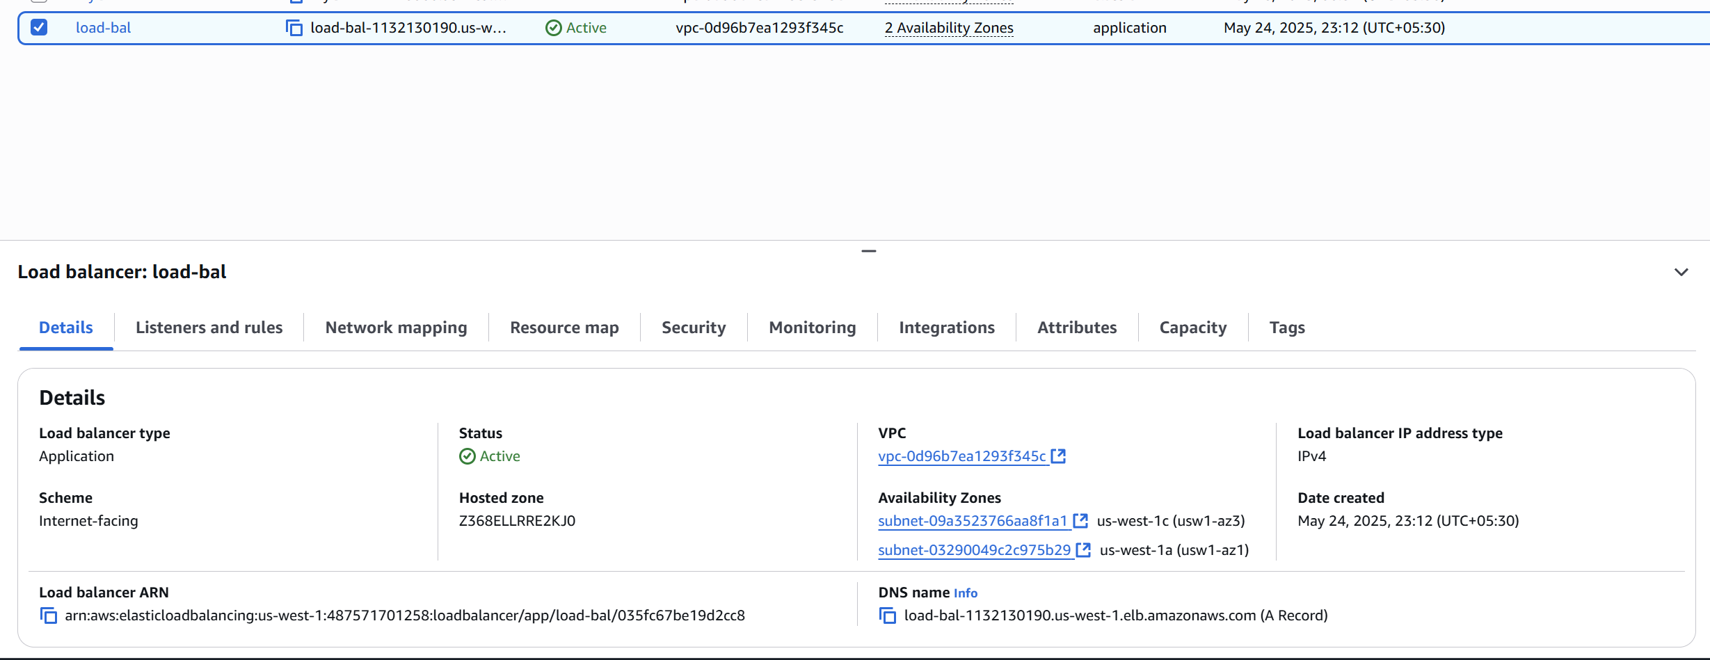

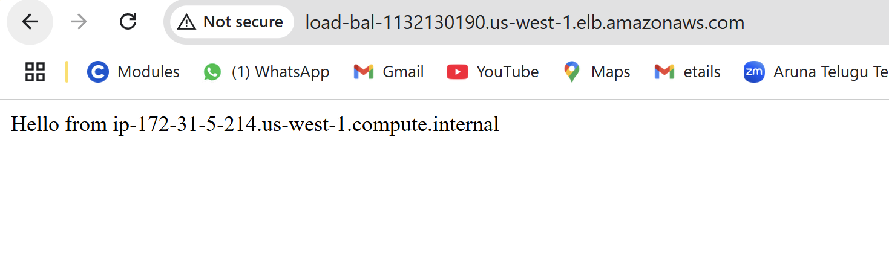

3) Configure Network Load balancer.

Step 1:

Make sure you have:

* At least **2 EC2 instances** running in **different Availability Zones**
* Your app/service running and listening on a specific **TCP port** (e.g., 80, 443, 8080, etc.)
* Security groups on EC2 instances allow inbound traffic on that port
* All instances are in the **same VPC**

Step 2: Create a Target Group

1. Go to **EC2 Console → Target Groups**
2. Click **Create target group**

**Target group settings:**

* **Target type:** Instance
* **Target group name:** my-nlb-targets
* **Protocol:** TCP
* **Port:** 80 (or your app port)
* **VPC:** Select your VPC

**Health Checks:**

* **Protocol:** TCP
* Leave other settings as default unless needed

Click **Next**

**Register Targets:**

* Select your EC2 instances
* Click **Include as pending**
* Click **Create target group**

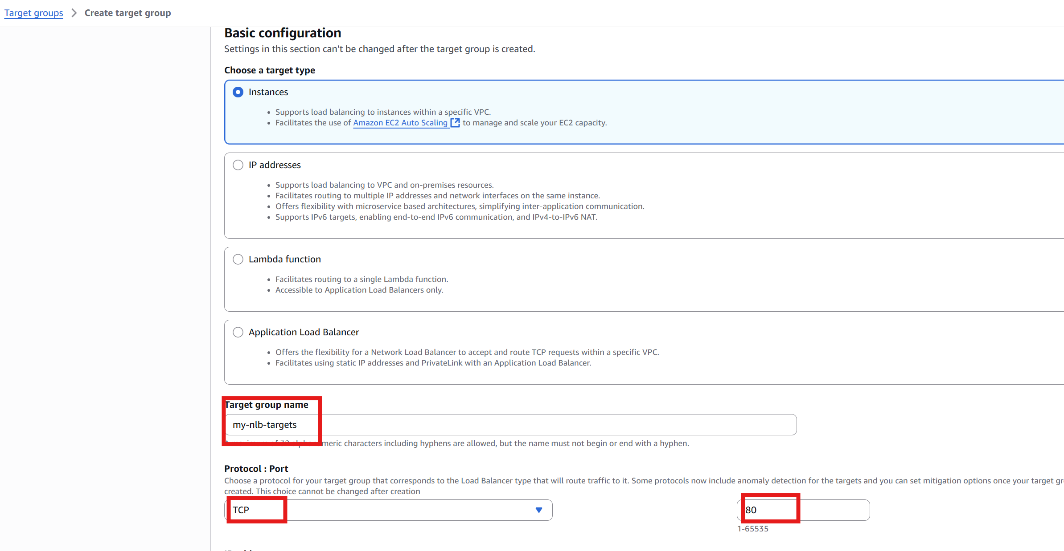

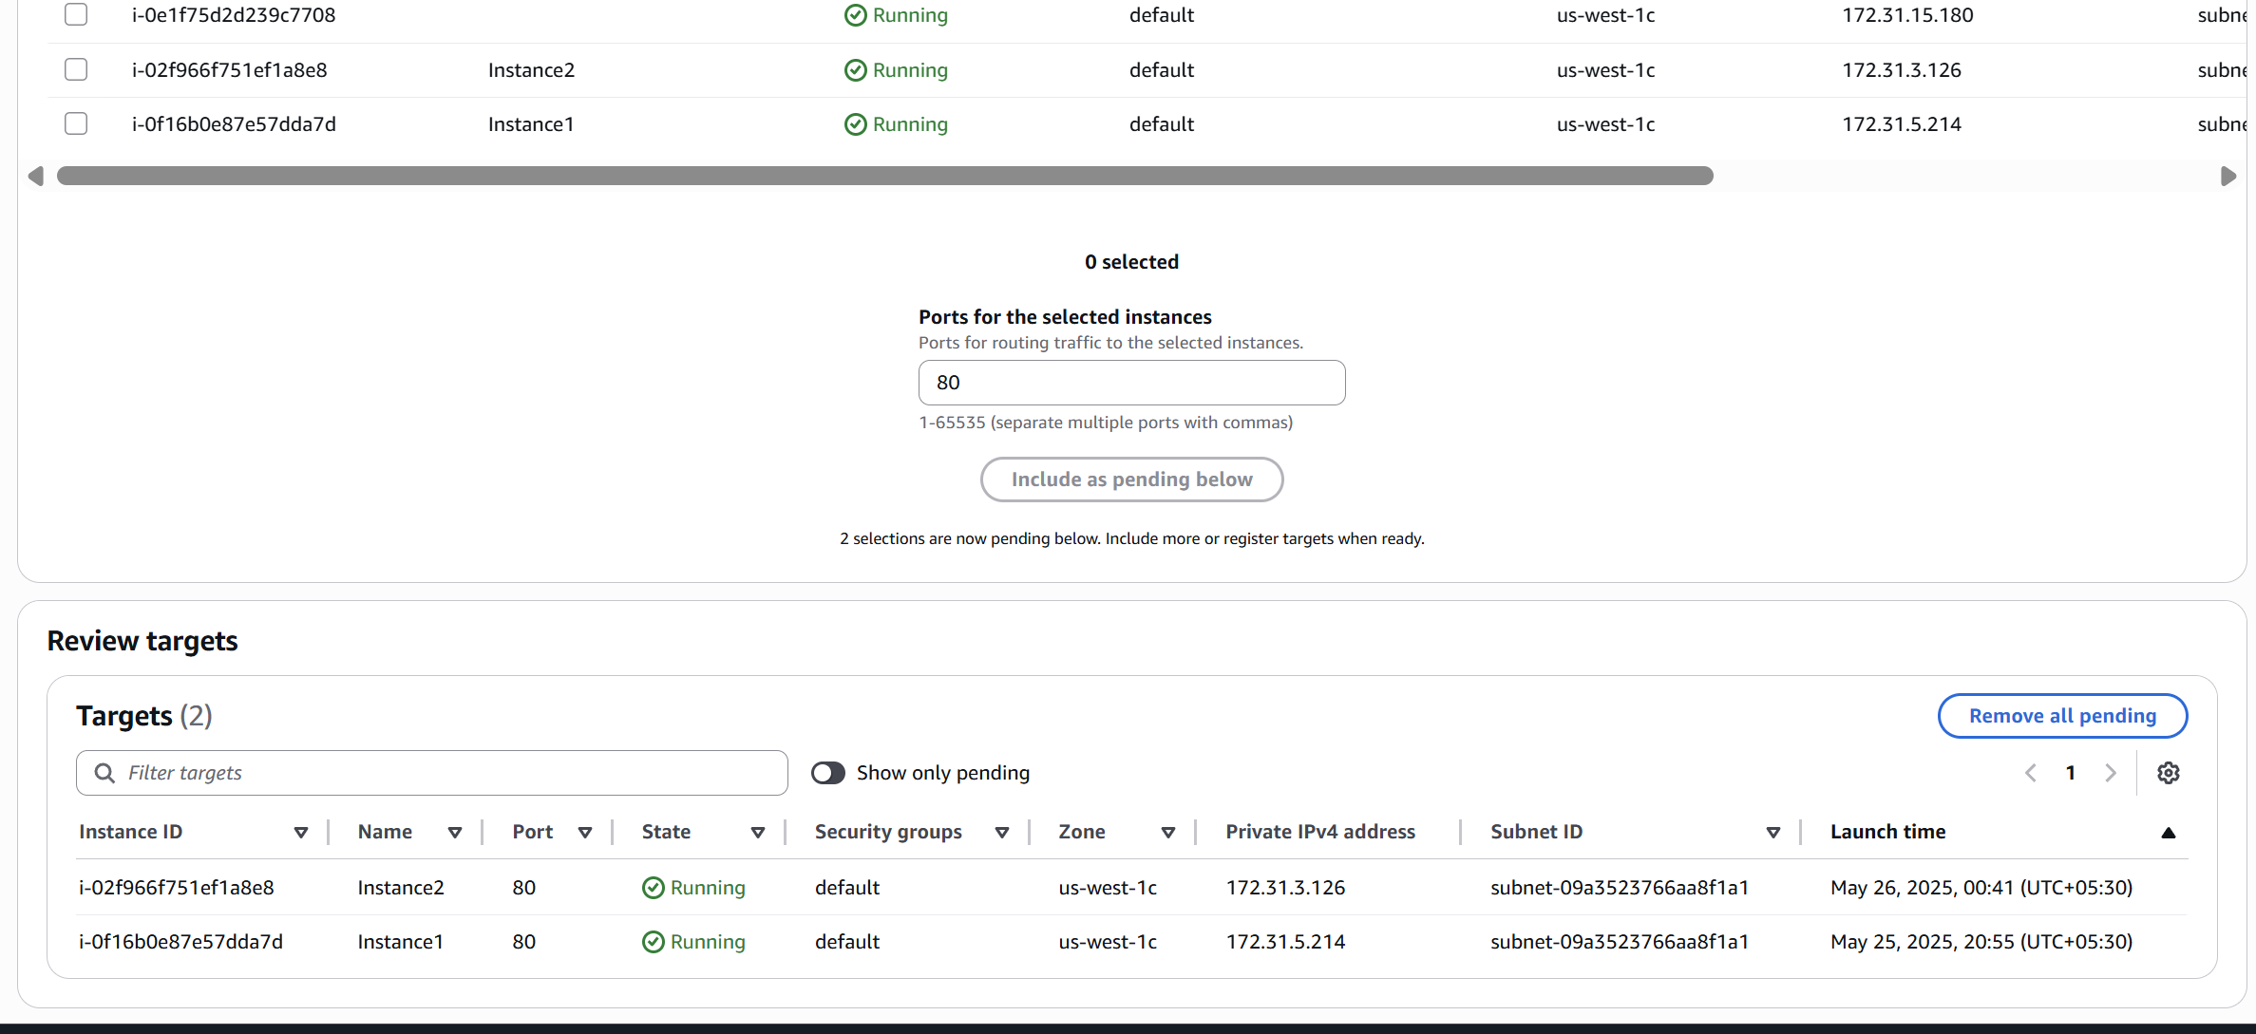

Step 3: Create Network Load Balancer

1. Go to **EC2 Console → Load Balancers**
2. Click **Create Load Balancer → Network Load Balancer**

**Basic Configuration:**

* **Name:** my-nlb
* **Scheme:** Internet-facing (or Internal)
* **IP address type:** IPv4 or dualstack (for IPv6)

**Network Mapping:**

* Select **at least two Availability Zones**
* Choose **one public subnet per AZ**

**Listeners:**

* **Protocol:** TCP
* **Port:** 80 (or your app's port)

Click **Next**

Step 4:Test NLB

Once the NLB is **active**:

1. Go to **Load Balancers → my-nlb**
2. Copy the **DNS name**
3. Open your browser and run

You should see a response from one of your EC2 instances.

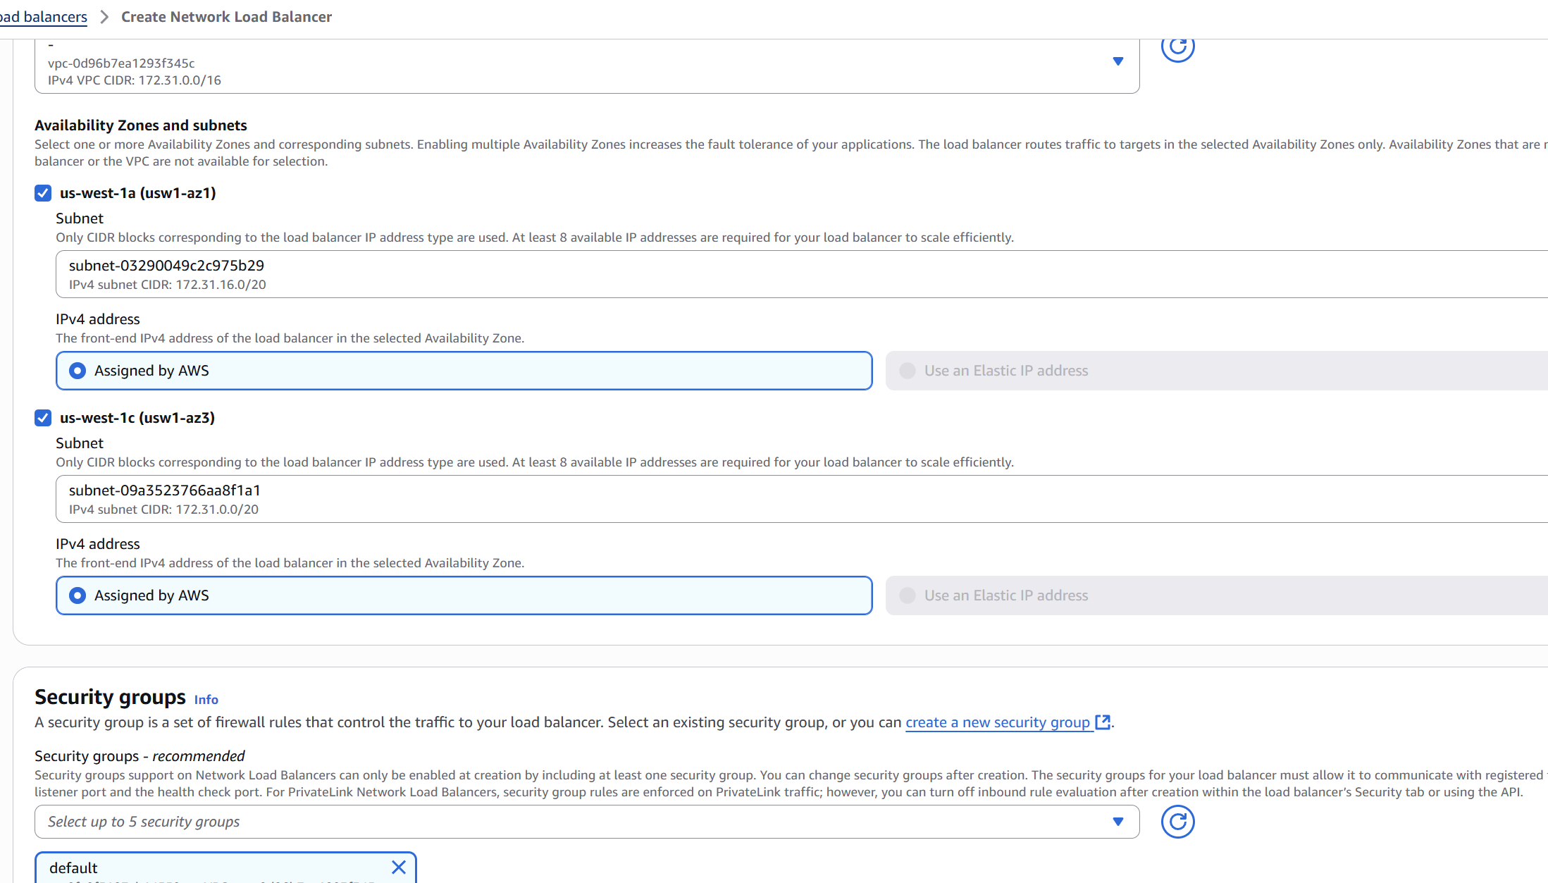

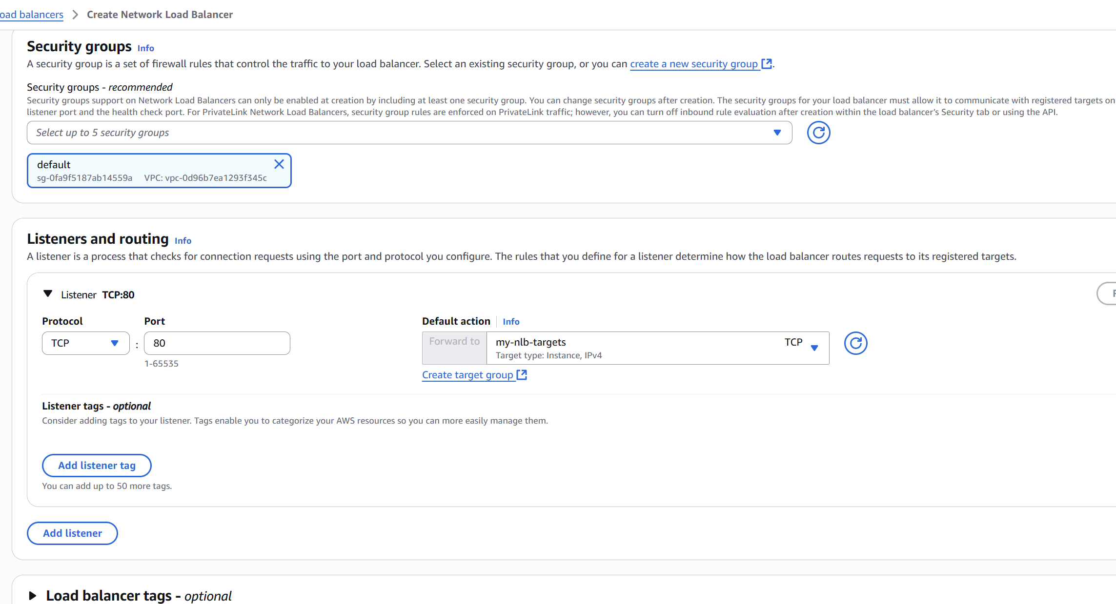

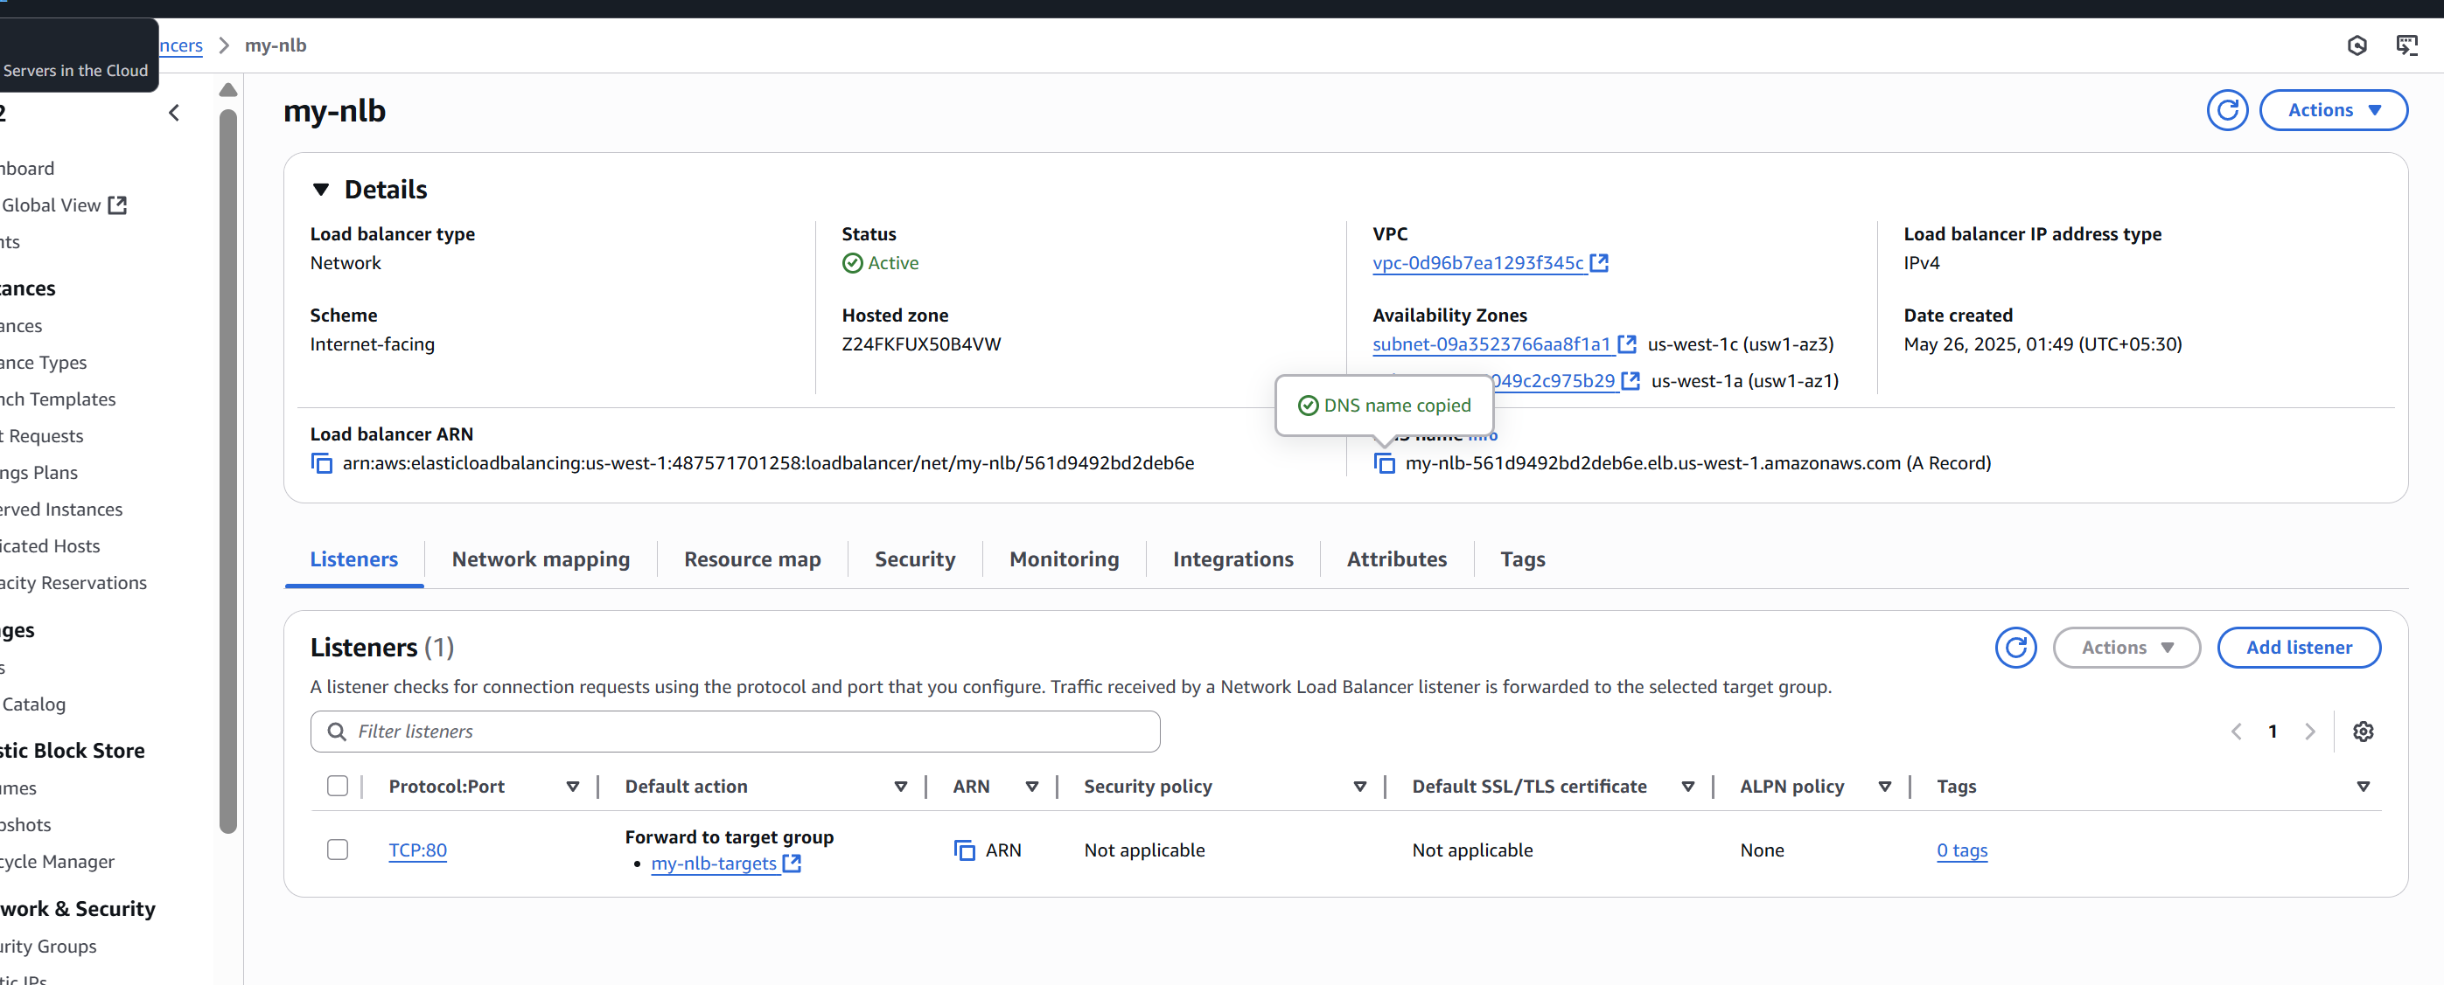

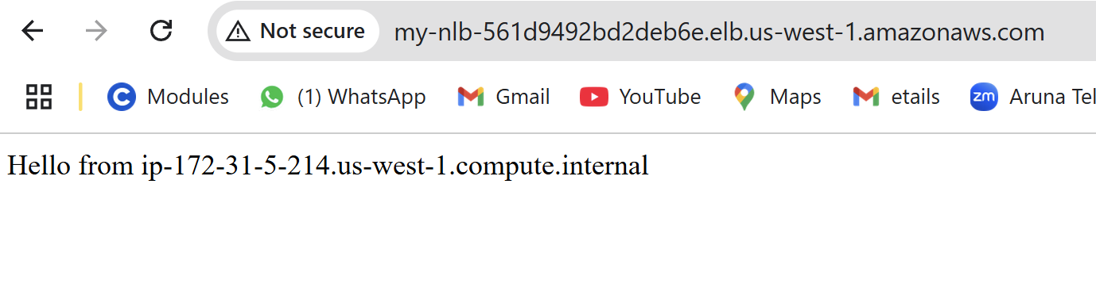

4) Attach SSL for application load balancer.

Step 1: Request an SSL Certificate using AWS Certificate Manager (ACM)  
1.     Go to **AWS Certificate Manager (ACM)** → <https://console.aws.amazon.com/acm>  
2.     Click **“Request a certificate”**  
3.     Choose **“Request a public certificate”** → Click **Next**  
4.     Enter your domain name (rachakondasushma.shop)  
5.     Click **Next**, then choose **DNS validation** (easier)  
6.     Add DNS CNAME record to your domain (AWS gives you this record)  
Wait until the status becomes **“Issued”**

**Step 2: Add HTTPS Listener to the Load Balancer**  
Go to **EC2 > Load Balancers**  
Select your **Application Load Balancer**  
Go to the **Listeners** tab  
Click **“Add listener”**  
Choose:  
**Protocol**: HTTPS  
**Port**: 443  
Under **Default action**, choose your **Target Group**  
Click **"Add certificate"**  
Select the SSL certificate you just created in ACM  
(Optional) Redirect HTTP (port 80) to HTTPS

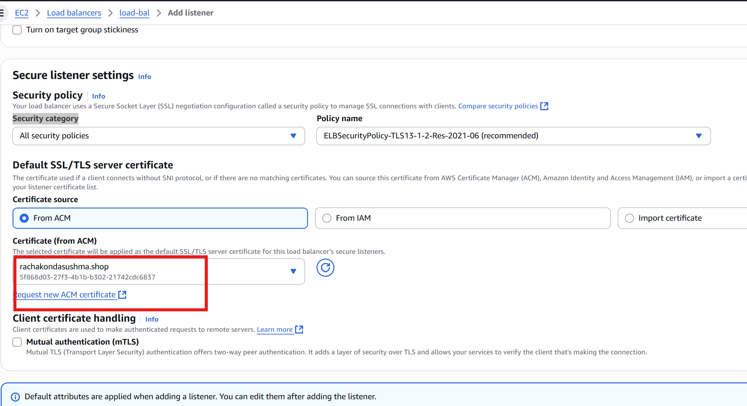

5) Map Applciation load balancer to R53.

**Step 1: Get Your ALB DNS Name**  
·       Go to **EC2 Console**  
·       Click on **Load Balancers** from the left menu  
·       Select your **Application Load Balancer**  
·       Copy the **DNS name**

**Step 2: Open Route 53**  
·       Go to the [**Route 53 Console**](https://console.aws.amazon.com/route53)  
·       In the left menu, click **"Hosted Zones"**  
·       Select your domain, e.g., rachakondasushma.shop**Step**

**3: Create a Record to Point to ALB**  
1.     Click **"Create Record"**  
2.     **Choose:**  
o  **Record Name:** leave blank if mapping to the root domain (rachakondasushma.shop)  
 OR enter www if you want [www.rachakondasushma.shop](http://www.rachakondasushma.shop)  
o  **Record Type:** **A – IPv4 address**  
o  **Alias:** **Yes**  
o  **Alias Target:** Click the search box → Select your **ALB** from the list  
3.     Click **"Create records"**  
Done! Your domain now points to your ALB.

**Step 4: Test It**

* Open your browser and enter:

[**https://rachakondasushma.shop**](https://rachakondasushma.shop)

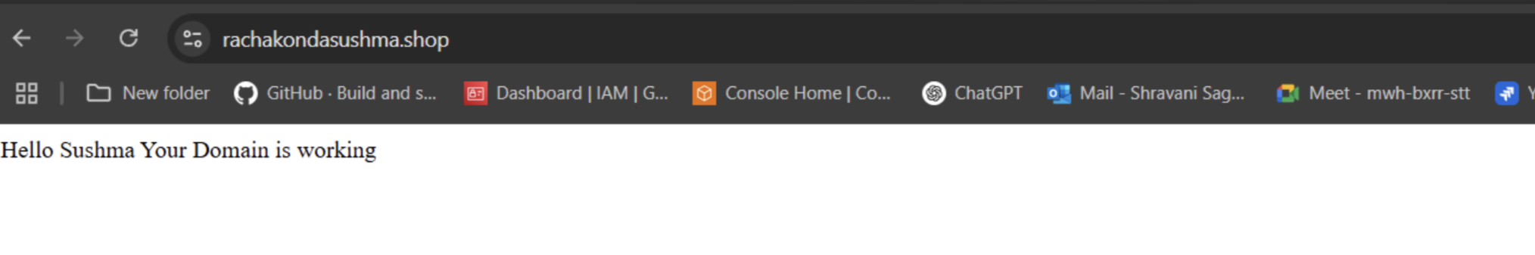

6) Push the application load balancer logs to s3.

Step 1: Create or Choose an S3 Bucket

You can use an existing bucket or create a new one.

**To create:**

1. Go to **S3 Console → Create bucket**
2. Name: my-alb-logs-bucket
3. Region: Same as your ALB
4. Uncheck "Block all public access" **only if needed for testing**
5. Click **Create bucket**

Step 2: Configure Bucket Policy for ALB Logging

**Go to:**

**S3 → your bucket → Permissions → Bucket policy**

{

"Version": "2012-10-17",

"Statement": [

{

"Sid": "AWSALBLoggingPolicy",

"Effect": "Allow",

"Principal": {

"Service": "logdelivery.elasticloadbalancing.amazonaws.com"

},

"Action": "s3:PutObject",

"Resource": "arn:aws:s3:::your-bucket-name/AWSLogs/*"

}

]

}

Step 3: Enable Logging on the ALB

* Go to **EC2 Console → Load Balancers**
* Select your **Application Load Balancer**
* Go to **Attributes** tab
* Click **Edit attributes**
* Check **Access logs: Enable**
* **S3 location:** your-bucket-name
* **Prefix (optional):** alb-logs/
* Click **Save changes**

Step 4: Now we can check our AppLB logs in S3 bucket.

